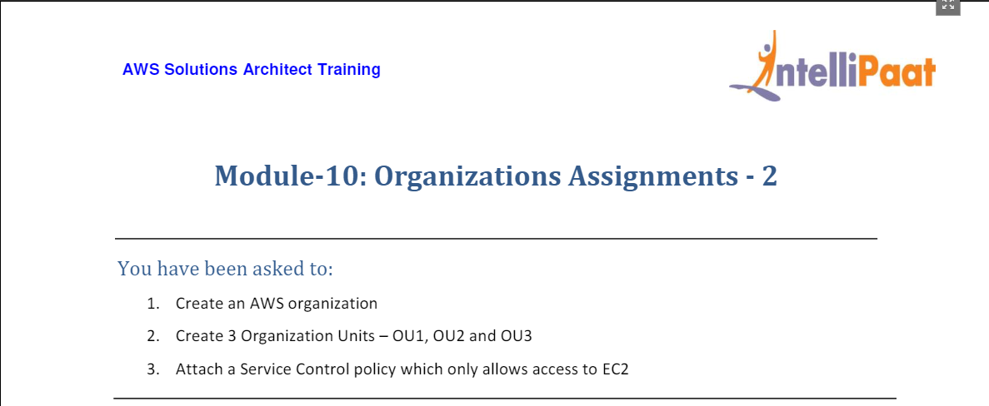

1. For this, we head to AWS Organization from Console home

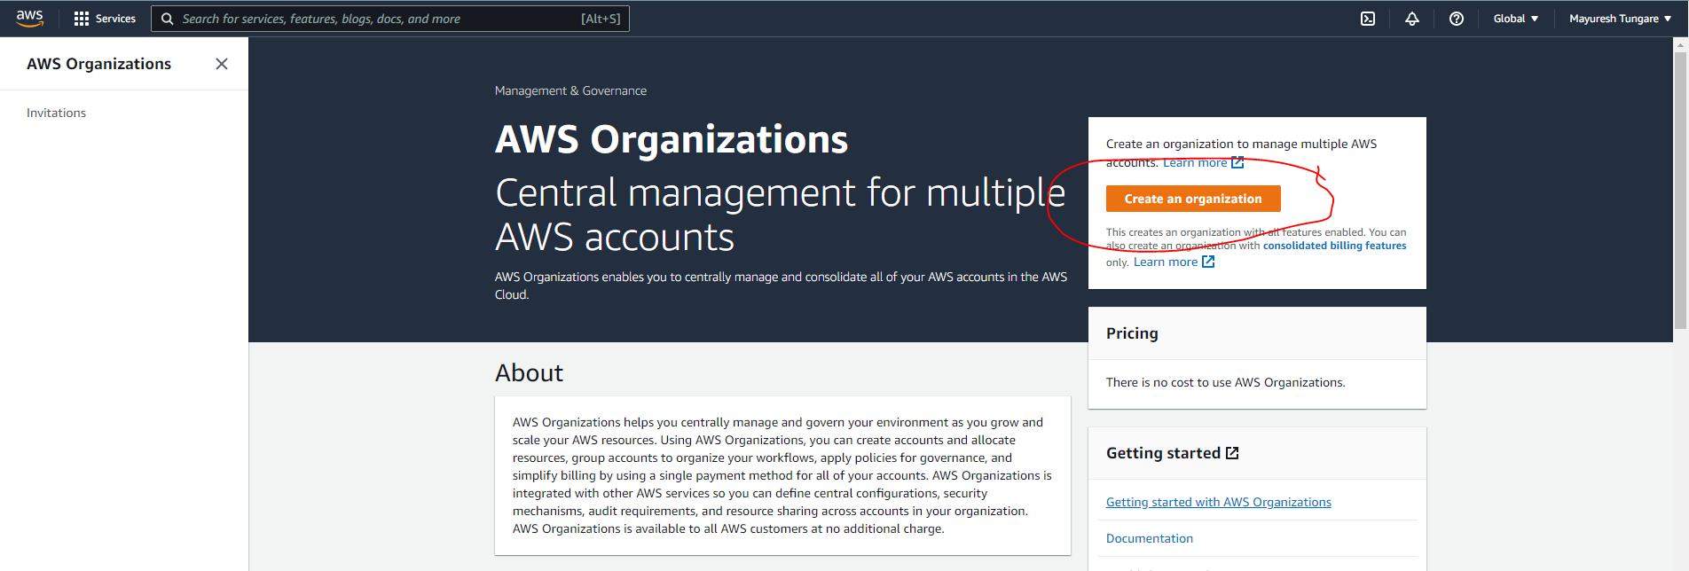

1. We see the following screen:

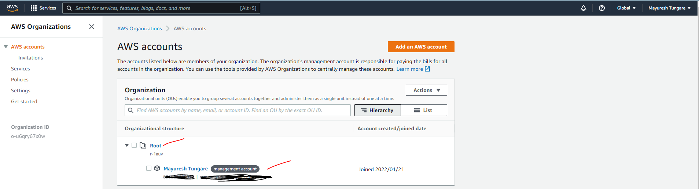

1. Then, we head to create new organization units:

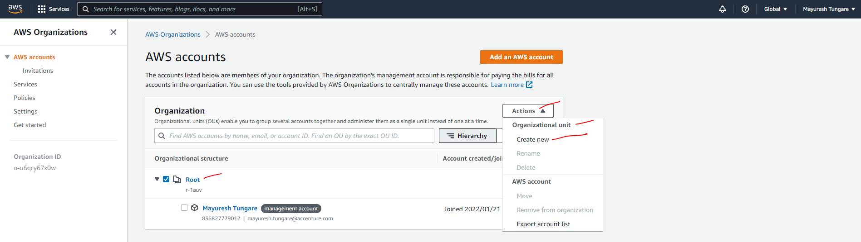

1. Now, we add three OUs – OU1, OU2 and OU3 as shown below:

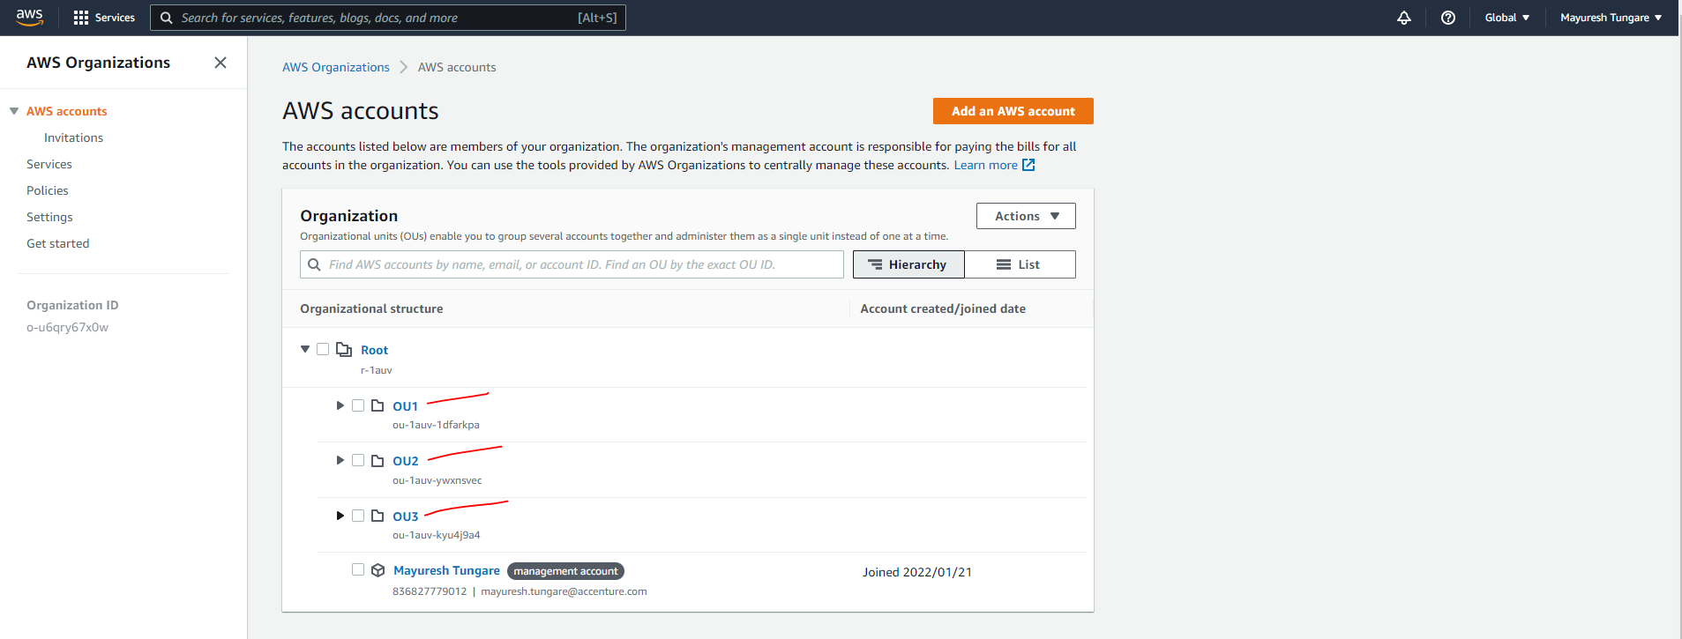

1. Next, we head to Policies to on the LHS side and see service policies are disabled by default. We manually enable service policies

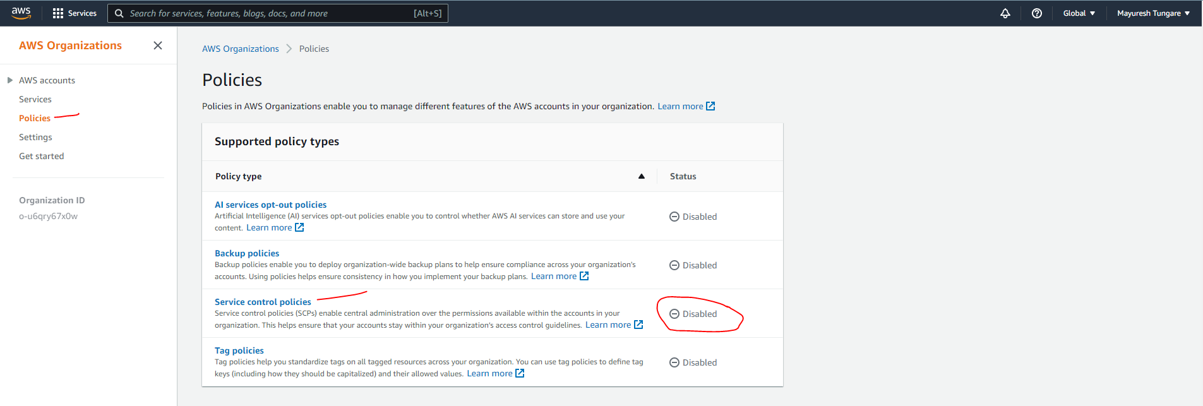

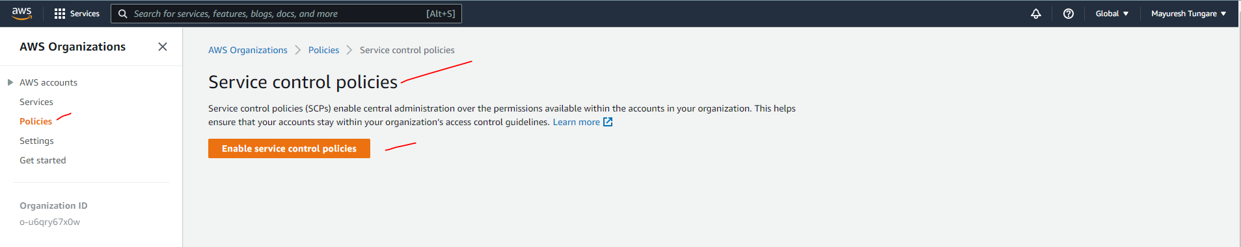

1. We see that Service Control policies have been enabled, so we add policy using create policy which only allows access to EC2.

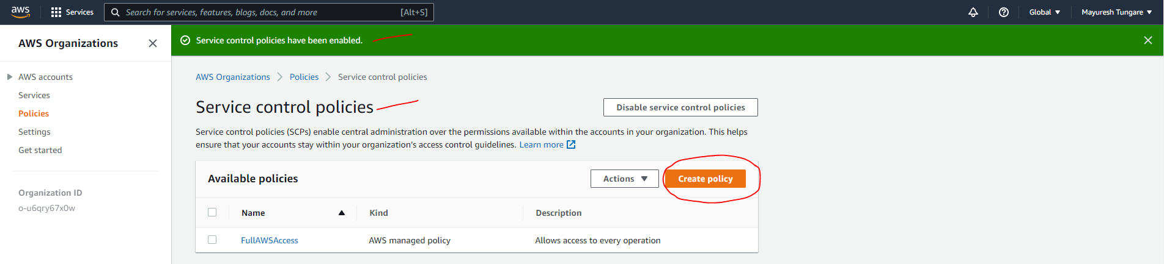

1. We then add policy and click on ‘Create policy’ as shown below.

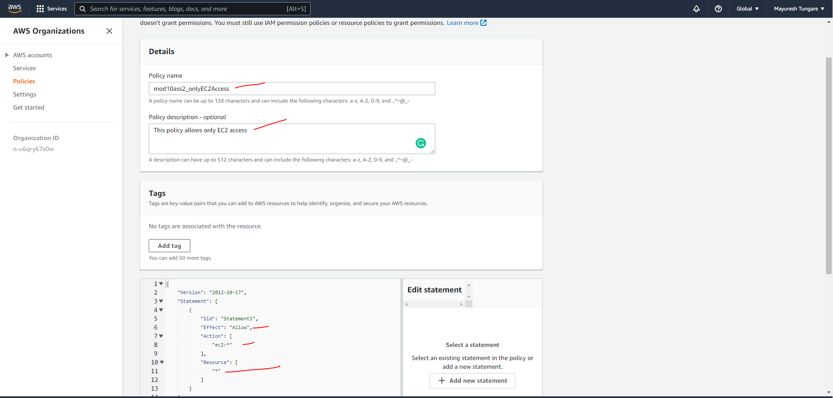

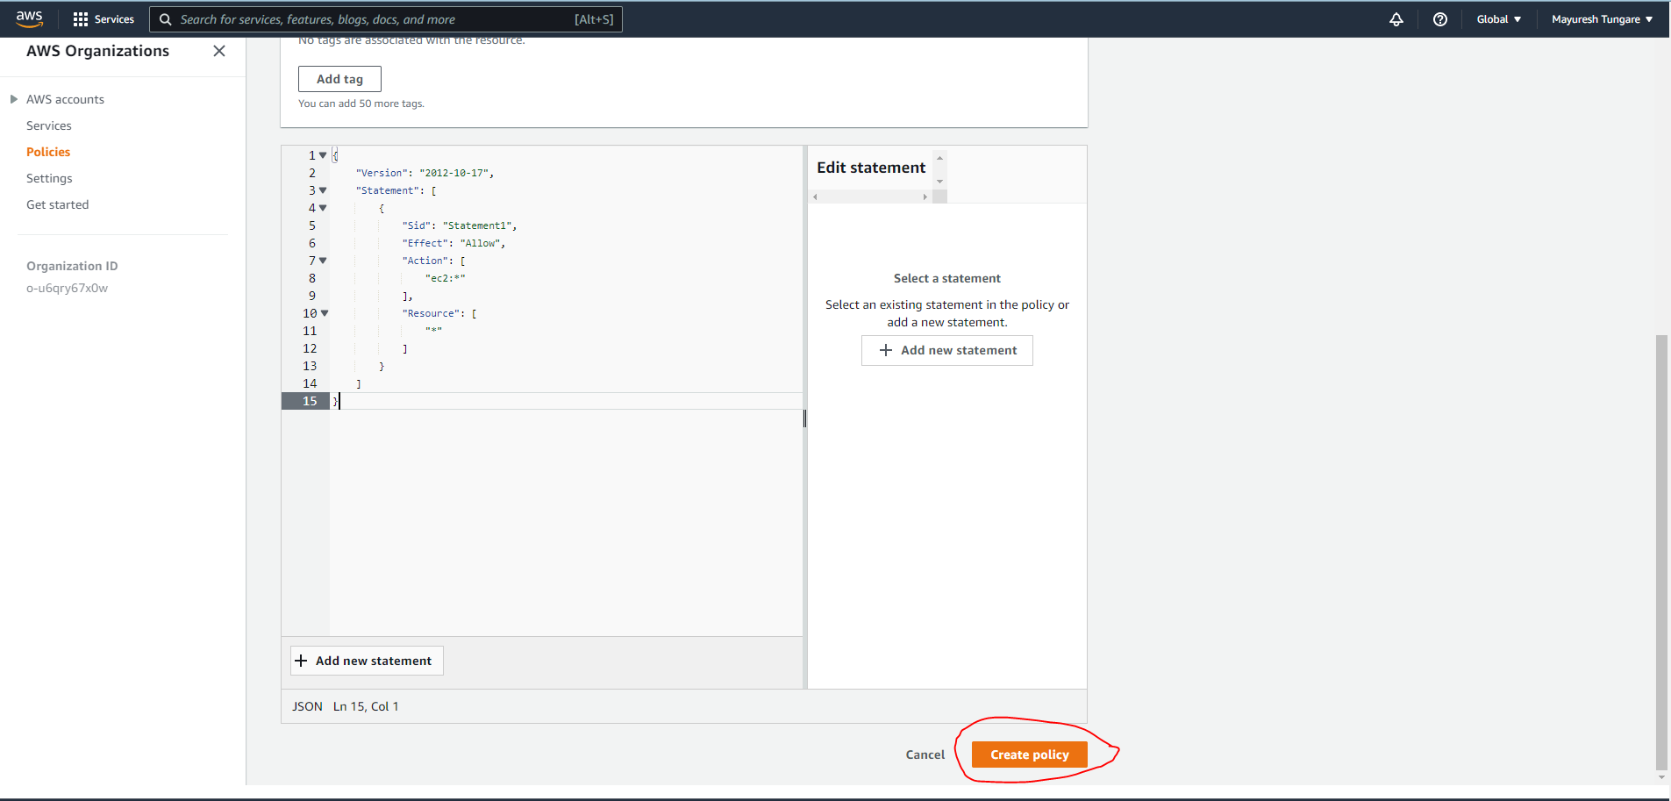

1. We observe that our policy has now been created:

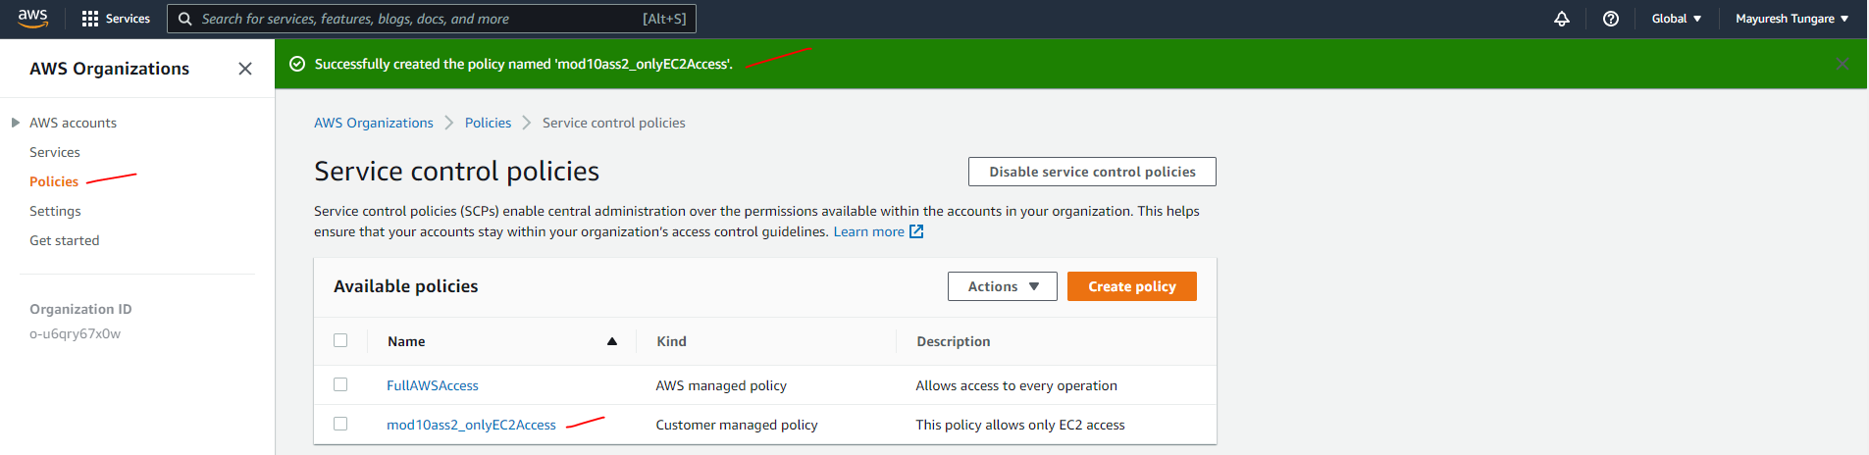

1. We now attach the policy to OU1

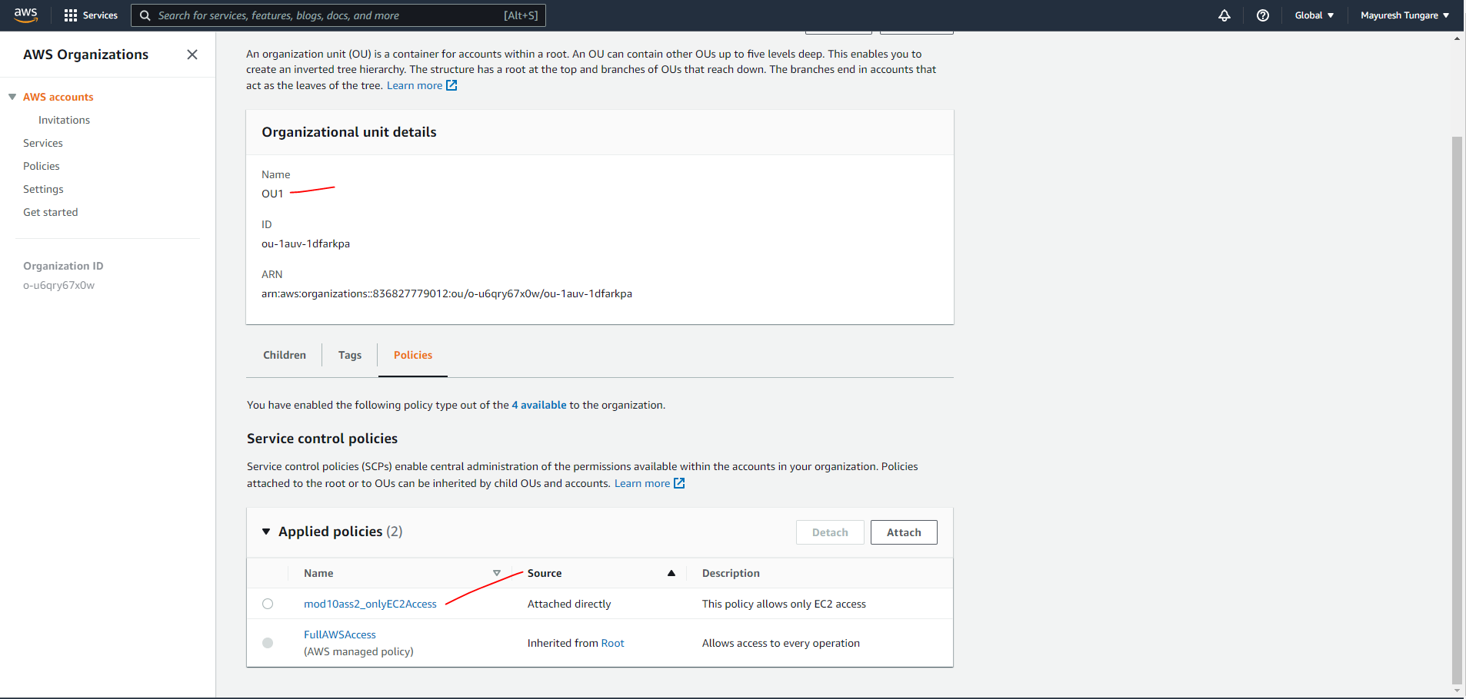

1. Similarly, we attach policy to OU2 and OU3.

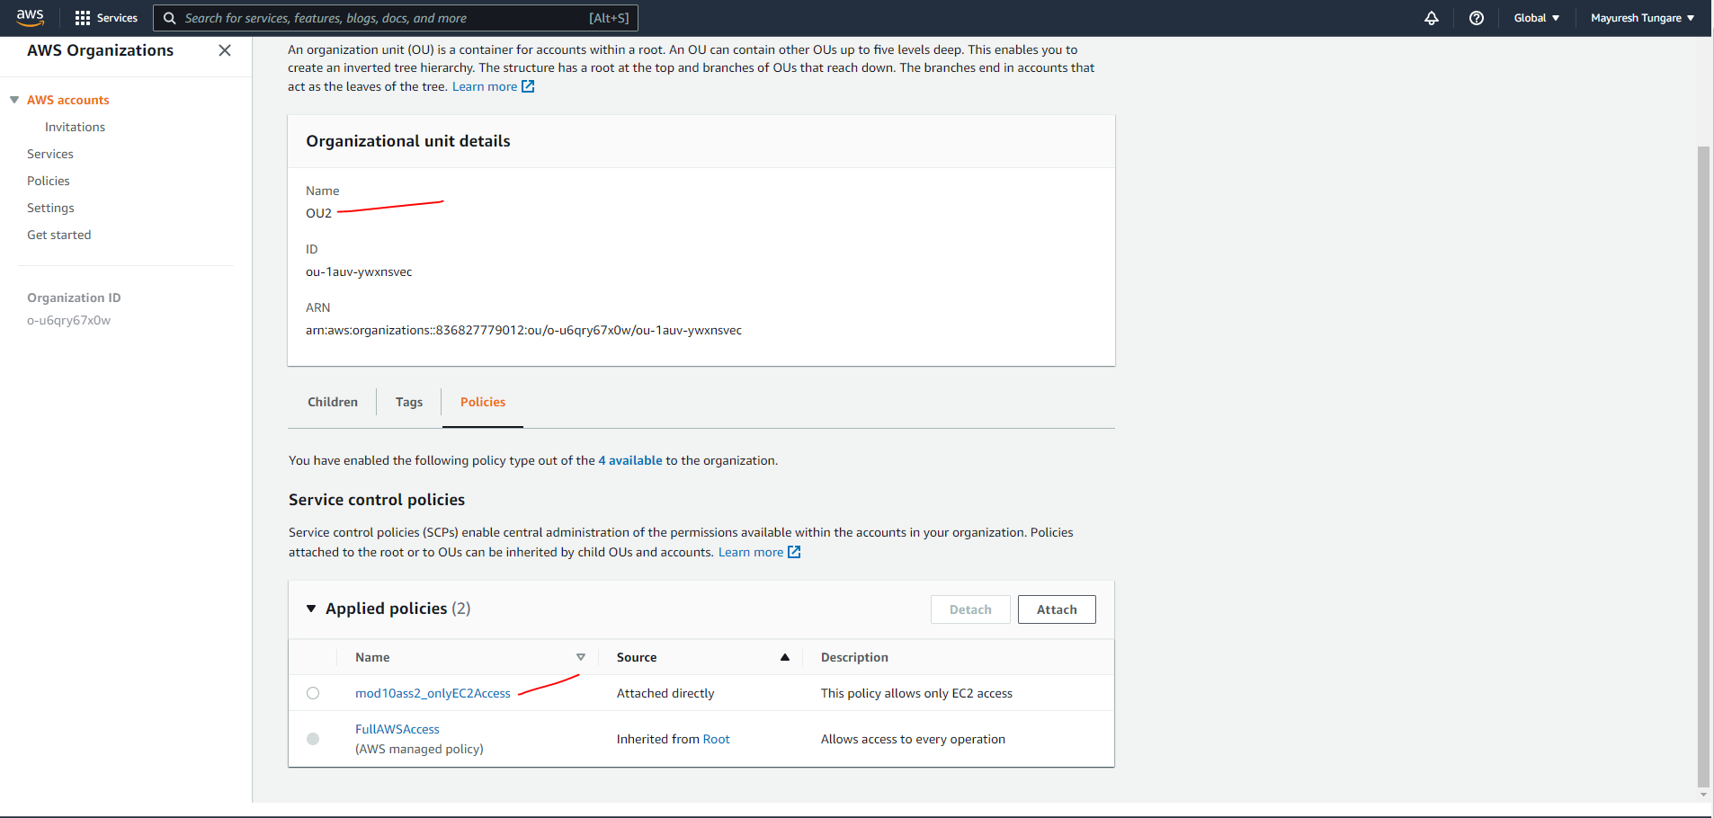

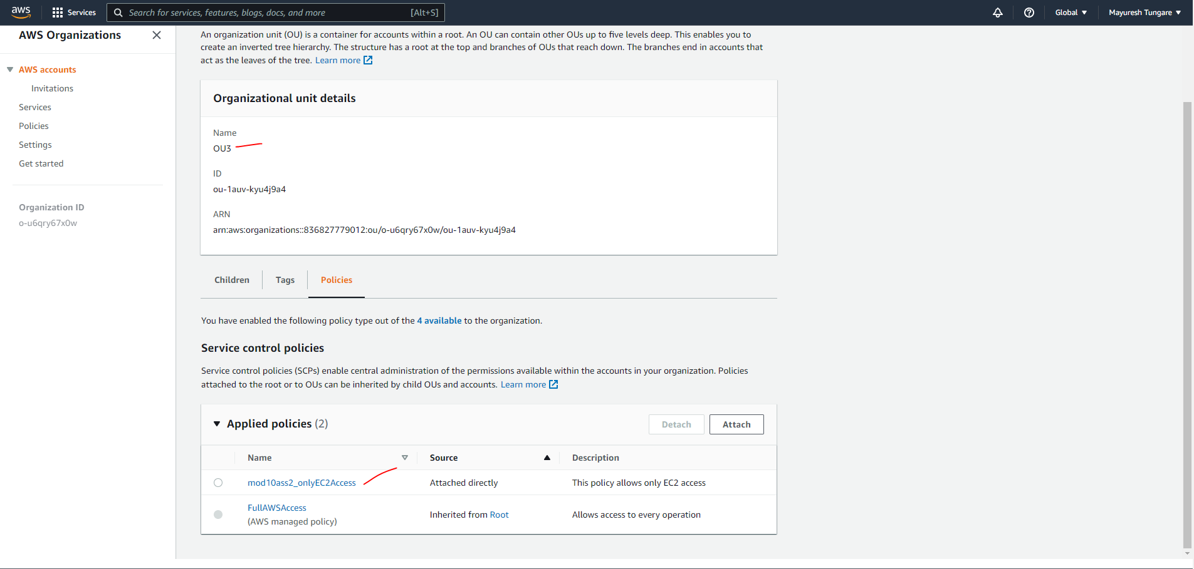

1. Thus, this assignment is now complete.